Cyber Security Fundamentals – Part B
Module Code: COMP40042
Module Name: Cyber Security Fundamentals
Student ID: 24030180

Contents
Introduction 1
Who Travelex Are 1
Broad Overview of What Happened 1
The Nature of the Ransomware Attack 1
Risk Assessment Elements and Processes 1
Malware 3
Brief Discussion of Malware 3
In Relation to the Case Study 4
Disaster Recovery 5
Brief Discussion of Disaster Recovery 5
In Relation to the Case Study 6
Idealised Risk Assessment and Conclusion 6
References 15

Introduction
This research report is about discussing risk assessment elements and processes regarding the case study of the ransomware attack against Travelex on December 31st, 2019. This report will begin by outlining the case study and discussing risk assessment elements and processes. Following that, the topics of malware and disaster recovery will be discussed in relation to the case study. To support this analysis, a hypothetical risk assessment will be produced from the perspective of an idealised version of Travelex as it existed in 2019. This will illustrate how the organisation might have identified and mitigated risks prior to the attack. Finally, the report will conclude by using evidence from the risk assessment to speculate about blind spots in Travelex’s actual risk assessments at the time relating to malware and disaster recovery.
Who Travelex Are
Travelex are a foreign currency exchange, undertaking services such as issuing prepaid credit cards or supplying central banks with foreign currency and global remittance (Travelex, 2025).

Broad Overview of What Happened
Travelex was hit by a ransomware attack on the 31st of December 2019. The threat group, called REvil (or Sodinokibi), a ransomware-as-a-service operation, allegedly stole five gigabytes of documents (Nish, Naumaan, & Muir, 2020), demanding $6 million to not publish on their blog, Happy Blog (Tidy, Joe, BBC News, 2021).
Travelex were reduced to pen and paper transactions (Tidy, Joe, BBC News, 2020). The first customer facing systems were restored on January 17th (OnSecurity, 2020).
Reports estimated that the attack ultimately cost Travelex $30 million, with $2.3 million reportedly being paid in ransom (Nish, Naumaan, & Muir, 2020). Travelex then filed for bankruptcy, citing the coronavirus epidemic and this particular cyberattack (Jaffee, Larry, SC Media, 2020).

The Nature of the Ransomware Attack
At the time of the ransomware attack, Travelex used Pulse Secure VPN presumably to allow for secure remote access to internal systems (at least this is what Ivanti Connect Secure, the rebranding of Pulse Secure VPN, claims it does currently (Ivanti, 2025)). However, an unpatched vulnerability in the software (CVE-2019-11510) (NIST, 2019) meant that many security features could be bypassed, with the description in the National Vulnerability Database reading “In Pulse Secure Pulse Connect Secure (PCS) 8.2 before 8.2R12.1, 8.3 before 8.3R7.1, and 9.0 before 9.0R3.4, an unauthenticated remote attacker can send a specially crafted URI to perform an arbitrary file reading vulnerability.” (NIST, 2019). Because of this REvil were able to gain access and allegedly encrypt and steal gigabytes worth of data.

Risk Assessment Elements and Processes
Risk assessment in cybersecurity involves four core concepts: assets, threats, vulnerabilities and risks. Risk assessment begins with an organisation identifying what assets they have that need protecting.
Next, potential threats are identified that could compromise those assets, followed by a discovery of what vulnerabilities exist on those assets. Threats are described in the NIST SP 800-30 Rev. 1 (2012, 2.3.1) as “any circumstance or event with the potential to adversely impact organizational operations and assets, individuals, other organizations, or the Nation through an information system via unauthorized access, destruction, disclosure, or modification of information, and/or denial of service”. It describes vulnerabilities as “a weakness in an information system, system security procedures, internal controls, or implementation that could be exploited by a threat source.”
The level of risk present is then assessed, which can be deduced by reasoning about the impact of the threat in comparison to its likelihood and using a chart known as a risk matrix. There are two main methodologies for identifying the level of risk present: quantitative or qualitative. Qualitative risk analysis involves ranking “threats on a relative scale to evaluate their risks, costs, and effects” and is “scenario-based, perception-based, or gut reaction-based than it is mathematically-based.” (Chapple, Stewart, & Gibson, 2024) Quantitative risk analysis “results in concrete probability indications or a numeric indication of relative risk potential” (Chapple, Stewart, & Gibson, 2024) and involves hard figures.
Depending on the level of risk assessed, an appropriate mitigation is proposed to prevent the threat damaging or stealing assets. There are five possible responses to risk:
Risk Response Definitions
Risk Response | Description
Risk Mitigation | “Implementing safeguards, security controls and countermeasures to reduce and/or eliminate vulnerabilities or block threats” (Chapple, Stewart, & Gibson, 2024)
Risk Assignment/ Risk Transfer | “With risk transference, an organization still takes on the risk of losing data in the event of equipment failure, theft, and disaster but transfers the risk of losing money to a third party.” (Heuermann, 2024)
Risk Deterrence | “Risk deterrence is the process of implementing deterrents to would-be violators of security and policy. The goal is to convince a threat agent not to attack. Some examples include implementing auditing, security cameras, and warning banners; using security guards; and making it known that the organization is willing to cooperate with authorities and prosecute those who participate in cybercrime.” (Chapple, Stewart, & Gibson, 2024)
Risk Acceptance/ Risk Exemption / Risk Exception | Risk acceptance is where an organisation is willing to accept a certain amount of risk. Either through exemption, due to the low impact of it happening, or exception, which is due to not having the resources to deal with it.
Risk Rejection | “An unacceptable possible response to risk is to reject risk or ignore risk. Denying that a risk exists and hoping that it will never be realized are not valid or prudent due care/due diligence responses to risk. Rejecting or ignoring risk may be considered negligence in court.” (Chapple, Stewart, & Gibson, 2024)

An effective risk assessment process will be both regular and thorough, monitoring how effective the mitigations have been and adjusting the risk assessment accordingly.

Malware

Brief Discussion of Malware
Malware stands for ‘malicious software’, that is software designed to infiltrate an IT system and cause some damage or theft without the user’s knowledge or consent. It includes “viruses, Trojan horses, spyware, ransomware, rootkits, keyloggers, and other types of undesirable software.” (Bayne, Smith, & Pickard, 2025).
The threats of malware are numerous, from stealing data to damaging or corrupting IT systems. Ransomware is a particularly powerful form of malware “which encrypts files and then holds them hostage until a ransom is paid’ or can deal reputational damage through ‘threatening to report the user to law enforcement due to pirated software or pornography, or threatening to expose sensitive information or pictures from the victim's hard drive or device” (Chapple & Seidl, 2023).
Anti-malware software can protect against malware by both preventing it from infecting endpoints and servers and removing it post-infection. A good anti-malware software works by “using a combination of signature-based detection, heuristic analysis, and behaviour-based monitoring” (Birch, 2025). Signature-based detection compares potentially malicious code to a database of known malware signatures, “which are unique identifiers such as code patterns, hashes, or byte sequences that correspond to specific malware samples.” (Birch, 2025) Heuristic analysis is a method of detecting new or modified malware that analyses code patterns to attempt to detect malware. Behaviour-based monitoring or behaviour analysis detects malware at runtime, when it may act suspiciously, carrying out actions such as modifying file systems or inducing unusually high CPU or memory usage.
Patch Management is another way to protect against malware. It involves making sure that patches are applied to known software vulnerabilities. Depending on what patches are being applied, patch management can help prevent avenues of attack, block malware and prevent malware spreading. Best practice in patch management requires “maintaining an accurate inventory of assets, their software versions, and update status, as well as policies that define deployment windows and patching responsibilities to ensure cyber resilience” (Nichols, 2024).

In Relation to the Case Study
Malware (specifically REvil ransomware) was the primary method through which REvil was able to allegedly steal up to five gigabytes of documents (Nish, Naumaan, & Muir, 2020). The ransom note would have looked like the following image:
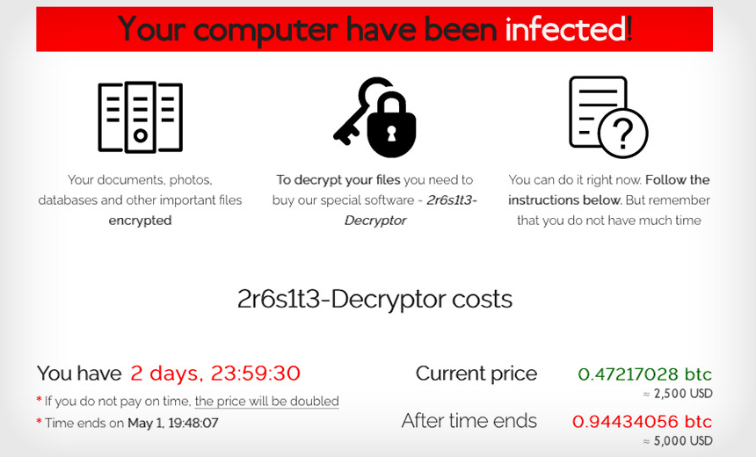
REvil ransom note, Image Source: (Schwartz, 2021)
Although Travelex claimed that “no customer data had been lost as a result of the attack” (OnSecurity, 2020), this is unlikely, as it is apparent that the files were at least encrypted, as there is evidence they paid REvil “$2.3 million in bitcoin” (OnSecurity, 2020). According to Lawrence Abrams (2020), “Sodinokibi Ransomware operators (Revil) published over 12 GB of stolen data allegedly belonging to a company named Brooks International for not paying the ransom”, thus indicating it is likely the malware was used to steal Travelex’s data at the time too, despite their protestations.
Although Travelex could have had some degree of anti-malware software in place on their systems, due to the fact that REvil is a “highly evasive and upgraded ransomware” (Heimdal Security, 2024), and it was a recently developed ransomware at the time, it is likely that Travelex’s anti-malware software was not up-to-date enough to combat REvil.
As previously discussed when talking about the nature of the ransomware attack, Travelex’s patch management was not as quick or comprehensive as it could have been, as they did not patch CVE-2019-11510, despite the vulnerability being widely known since May 2019 (NIST, 2019).

Disaster Recovery

Brief Discussion of Disaster Recovery
Disaster recovery is the process of creating procedures by which IT infrastructure, data and business operations can be restored after incidents that cause disruption or systems outages.
Without a disaster recovery plan, an organisation will open itself up to significant financial and reputational loss in the event it cannot carry out its main purposes.
A good disaster recovery plan can be measured by three primary metrics: high availability (HA), recovery point objective (RPO) and recovery time objective (RTO).
Disaster Recovery Metric Definitions
Metric | Definition
High Availability (HA) | HA is the “system’s ability to remain operational and accessible for extended periods, minimizing downtime through redundancy and fault tolerance” (Mishra, Qu, & Challa, 2025). HA is measured as a percentage, with 100% indicating no downtime of service whatsoever. A common goal for HA is five-nines (99.999% availability), but “for less critical applications or services with a lower level of availability, such as 99% or 99.9%, may be more realistic and achievable within reasonable resource constraints.” (Kumar & Singh, 2025)
Recovery Point Objective (RPO) | RPO is the more data-centric metric of the two recovery metrics, referring to “the maximum amount of time for data loss … it is also measured in time and is impacted by when the last backup was taken. If you had taken a backup 30 minutes before the disaster, you would lose 30 minutes” worth of data. If you have an RPO of 15 minutes, you should take backups every 15 minutes or less.” (Thalpati, 2024)
Recovery Time Objective (RTO) | RTO is the more service-centric metric of the two recovery metrics, referring to “how quickly you need to restore your service to operation after a disruption. An RTO of four hours means your system must be back online within four hours of an incident.” (Mishra, Qu, & Challa, 2025)

A good disaster recovery plan will involve regular drills, to ensure that it can achieve the HA, RPO and RTO targets in an environment that is as close to emulating a real-world incident as possible.

In Relation to the Case Study
It is clear disaster recovery was a problem during the ransomware attack on Travelex in 2019.
Firstly, it took Travelex until January 17th to get their customer facing services back online (OnSecurity, 2020). This indicates that there was either a lack of disaster recovery drills carried out prior to this, or that any disaster recovery drills were not fit for purpose. The fact that Travelex cited this and the coronavirus pandemic as key reasons for filing for bankruptcy also indicates that more than two weeks of downtime is far beyond the RTO objective, and common sense would draw the same conclusion.
In terms of HA, because Travelex’s services went down for so long indicates either that the REvil malware had infected Travelex’s infrastructure so comprehensively that any mechanisms designed to ensure HA were ineffectual, or that systems designed to ensure HA were not designed and tested well enough.
Due to not having services online, and the malware having encrypted data, it is likely that RPO metrics were missed initially, and that they became irrelevant when during this period no data would have been recorded regarding the customer facing services.

Idealised Risk Assessment and Conclusion
The risk score in the following risk assessment is calculated using the following Risk Matrix and only acts on qualitative values, which may or may not be influenced by quantitative values:

Risk Matrix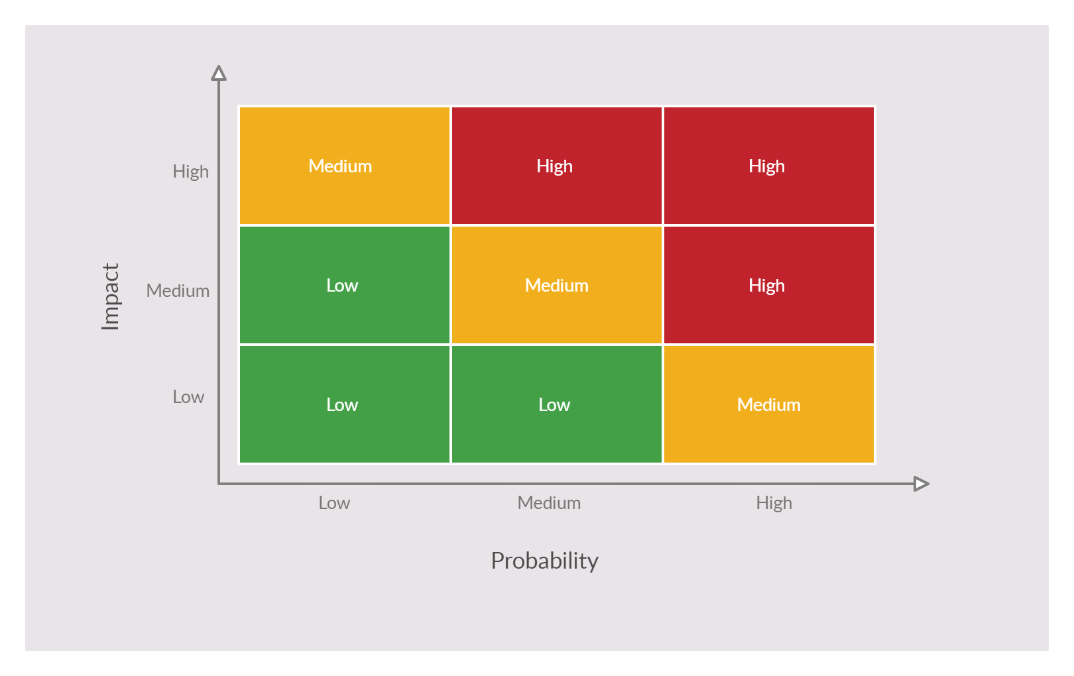

The following is an idealised risk assessment produced from the hypothetical perspective of Travelex before the cyberattack, perhaps in the months preceding it. This risk assessment uses both qualitative and quantitative risk analysis, but focuses mainly on qualitative, only using quantitative where information is freely available to the public (or reasonable conclusions that can be drawn from publicly available sources). This risk assessment specifically focuses on the malware and disaster recovery concepts discussed previously and uses previously discussed points as reference.
Risk Assessment 1
Asset ID | Asset Name | Threats | Vulnerabilities
1 | Customer Facing Web Application | Malware through SQL injection when uploading customer information.  Direct Denial of Service (DDoS) attacks may leave the infrastructure unable to provide services to customers. | Lack of separate backups for infrastructure such the web application needs, such as databases and servers. A malware attack that infected any of these pieces of infrastructure could result in service outages lasting several weeks.
Likelihood of Occurrence | Impact | Risk Score | Proposed Treatment
Medium. Travelex may come under attack from ransomware-as-a-service groups or hacktivists. | High. The incident could result in prolonged service outages lasting several weeks due to the time required to re-provision cloud/ on-premises infrastructure. Such disruptions may significantly harm the organisation’s reputation and potentially lead to financial insolvency. | High | Disaster recovery drills should be conducted following the provisioning of backup infrastructure to ensure seamless switchover in the event of a critical incident. These exercises must validate that the RTO remains within a target threshold of a few hours, and that the RPO does not exceed thirty minutes. Additionally, backup systems should be tested to confirm congruence with production environments. Comprehensive software testing is essential to prevent the upload of malicious content through customer-facing platforms.

Risk Assessment 2
Asset ID | Asset Name | Threats | Vulnerabilities
2 | Servers, Endpoints and Networked Devices | Malware could spread across networked systems, potentially facilitating unauthorised access to databases and enabling widespread infection throughout the networked environment. | Software vulnerabilities and a lack of cutting-edge anti-malware software on devices. Of note is vulnerability CVE-2019-11510 in the National Vulnerability Database, through which an attacker can gain access to internal systems through our Pulse Secure Connect VPN service, bypassing the need for credentials. (NIST, 2019)
Likelihood of Occurrence | Impact | Risk Score | Proposed Treatment
High. Due to known vulnerability CVE-2019-11510 | High, in the case of ransomware-as-a-service operations, millions of dollars could be requested to unencrypt data. Reputational damage could be substantial. GDPR could also issue fines up to £17.5 million or 4% of our annual turnover, whichever is greater (Information Commissioner's Office, 2024). (Note: the fines refer to the Data Protection Act 2018, so the reference of 2024 is applicable) | High | Patch management systems should be enhanced to ensure timely identification and application of relevant software updates. Organisational resources must be allocated to maintain software environments in a state that reflects the most current security standards. Systems running vulnerable software should be catalogued and prioritised for remediation. Additionally, anti-malware solutions should undergo quarterly evaluations to ensure the deployment of advanced, industry-leading software to mitigate threats.

Risk Assessment 3
Asset ID | Asset Name | Threats | Vulnerabilities
3 | Databases | Malware infection may result in the stealing or encryption of sensitive data, data integrity loss or the disruption of critical services. | Lack of backups of data. Lack of HA. Lack of cutting-edge anti-malware software on databases.
Likelihood of Occurrence | Impact | Risk Score | Proposed Treatment
Medium. Travelex may come under attack from ransomware-as-a-service groups or hacktivists. | High. The consequence of a ransomware-as-a-service attack would likely mirror those associated with those highlighted for Assets 2 and 3. Should data become corrupted or irretrievably lost; the resulting operational downtime could lead to significant reputational harm, substantial financial losses, and potential regulatory penalties under GDPR. | High | Implement geo-redundant backups for all critical databases to ensure data availability across multiple regions. These backups should be rigorously tested during disaster recovery drills to confirm their effectiveness. The recovery process must consistently meet the defined RPO of 30 minutes. Systems should be capable of restoring database congruency across sites to maintain operational continuity.

Risk Assessment 4
Asset ID | Asset Name | Threats | Vulnerabilities
4 | Customer Data | Stolen, encrypted or destroyed via malware attack. | Vulnerabilities would be related to the vulnerabilities listed above for Assets 1,2 and 3.
Likelihood of Occurrence | Impact | Risk Score | Proposed Treatment
Medium. By itself customer data may not be that useful to hacktivist groups but could be used by ransomware-as-a-service groups to hold the organisation to ransom. | Medium, contingent on the volume of customer data affected. If the amount of data affected is limited, the impact may be moderate. A larger breach, however, could be disastrous and would elevate the impact to high. The most significant consequence would be regulatory action under GDPR, including substantial fines. Additionally, litigation from affected individuals may arise. Reputational damage would depend on the scope of the data breach. | Medium/ High | Mitigation should involve only holding on to required data for as long as necessary to comply with the Data Protection Act (UK Government, 2018). Otherwise, see the sections for Assets 1,2 and 3.

Risk Assessment 5
Asset ID | Asset Name | Threats | Vulnerabilities
5 | Financial Data | Stolen, encrypted or destroyed via malware attack. | Vulnerabilities would be related to the vulnerabilities listed above for Assets 1,2 and 3.
Likelihood of Occurrence | Impact | Risk Score | Proposed Treatment
Medium. Similar to the likelihood of Asset 4, but more weighted towards being targeted by hacktivist groups that could try to expose individuals or organisations’ financial dealings. | High. A breach involving financial data could expose the organisation to more severe legal consequences than those associated with personal data, including high-value litigation and regulatory penalties under GDPR. The reputational impact would be substantial, potentially undermining long-term financial stability. | High | Mitigation should involve ensuring the databases containing financial data are secured to the highest standards. Advanced anti-malware solutions must be deployed on these systems, and all connected devices should be fortified against compromise through a multi-layered defence strategy.

Risk Assessment 6
Asset ID | Asset Name | Threats | Vulnerabilities
6 | Employee Credentials | Stolen credentials could be used to bypass security features | Threat actors gaining access to personal devices, as well as the vulnerabilities associated with Customer Facing Web Applications, Servers, Endpoints and Networked Devices and Databases.
Likelihood of Occurrence | Impact | Risk Score | Proposed Treatment
Medium. Travelex may come under attack from ransomware-as-a-service groups or hacktivists. | Medium. Whilst it is unlikely the compromised credentials would grant sufficient privileges to bypass core security controls; the potential impact remains significant if credentials belonging to high-privilege users were obtained. Such an event could facilitate unauthorised access to sensitive systems and data, resulting in considerable operational and reputational consequences. | Medium | Mitigation strategies should include the deployment of advanced anti-malware solutions on personal devices used for work-related activities. Personnel should receive regular security awareness training or recognise and respond to potential threats. Password policies must enforce periodic changes, ideally on a quarterly basis. Additionally, access controls should follow the principle of least privilege, ensuring that employees are granted only the minimum level of access necessary to perform their roles.

This risk assessment highlights several critical threats and vulnerabilities that Travelex did not protect themselves from adequately. Of note is that all the assets except for Asset 6 have a risk score of High. Had Travelex proactively carried out the mitigations recommended on this hypothetical risk assessment, it is unlikely that they would have been affected by the REvil ransomware attack on December 31st, 2019. This is because, through better patch management, vulnerability CVE-2019-11510 would not have been exploited by REvil. This means that the malware would not have propagated itself throughout Travelex’s cloud estate, thus making it unable to steal and encrypt customer data. The mitigations of better anti-malware software and better disaster recovery drilling and hitting key disaster recovery performance metrics would have given Travelex a good defence-in-depth security strategy, potentially preventing other forms of cyberattack which could have, under different circumstances, been carried out by other threat actors. Smaller mitigations such as password policies and using the principle of least privilege would have not had much of an impact on the particulars of the case study but would have given Travelex even more security assurance risk mitigation and deterrence.
Ultimately, the coronavirus pandemic may have still led to Travelex’s bankruptcy, but had they carried out the mitigations listed in the risk assessment instead of pursuing either intentional or negligent risk rejection, they could have fared much better in 2020, having not suffered severe financial and reputational damage.

References
Abrams, L. (2020, March 19th). Sodinokibi Ransomware Data Leaks Now Sold on Hacker Forums. Retrieved from Bleeping Computer: https://www.bleepingcomputer.com/news/security/sodinokibi-ransomware-data-leaks-now-sold-on-hacker-forums/
Bayne, D., Smith, M., & Pickard, J. (2025). CompTIA A+ Core 1 (220-1201) and Core 2 (220-1202) Exam Cram, Part II (10th ed.). Pearson IT Certification.
Birch, M. (2025). CompTIA® SecurityX® CAS-005 Certification Guide (2nd ed.). Packt Publishing.
Chapple, M., & Seidl, D. (2023). CompTIA Security+ Study Guide with over 500 Practice Test Questions, Chapter 3 (9th ed.). Sybex.
Chapple, M., Stewart, J. M., & Gibson, D. (2024). ISC2 CISSP Certified Information Systems Security Professional Official Study Guide, Chapter 2 (10th ed.). Sybex.
Heimdal Security. (2024, February 22nd). REvil/Sodinokibi Ransomware: Origin, Victims, Prevention Strategies. Retrieved from Heimdal Security: https://heimdalsecurity.com/blog/sodinokibi-ransomware-101/
Heuermann, L. (2024). CompTIA Security+ SY0-701 Cert Guide, Part V. Pearson IT Certification.
Information Commissioner's Office. (2024, March). Data Protection Fining Guidance. Retrieved from ICO: https://assets.publishing.service.gov.uk/media/6763eb1fe6ff7c8a1fde9ba4/information_commisner_data_protection_fining_guidance.pdf
Ivanti. (2025, August 8th). Main Page. Retrieved from Ivanti: https://www.ivanti.com/company/history/pulse-secure
Jaffee, Larry, SC Media. (2020, August 10th). Travelex driven into financial straits by ransomware attack. Retrieved from SC World: https://www.scworld.com/news/travelex-driven-into-financial-straits-by-ransomware-attack
Kumar, J., & Singh, M. (2025). System Design on AWS, Chapter 1. O'Reilly Media, Inc.
Mishra, S., Qu, D., & Challa, A. (2025). AWS Certified Data Engineer Associate Study Guide. O'Reilly Media, Inc.
Nichols, L. (2024). Cybersecurity Architect's Handbook, Chapter 1. Packt Publishing.
Nish, A., Naumaan, S., & Muir, J. (2020, November). Enduring Cyber Threats and Emerging Challenges to the Financial Sector. Retrieved from Carnegie Endowment For International Peace: https://carnegie-production-assets.s3.amazonaws.com/static/files/NishNaumaan_FincyberThreatsChallenges_v3.pdf
NIST. (2012, September). NIST Special Publication 800-30: Guide for Conducing Risk Assessments. Retrieved from nvlpubs.nist.gov: https://nvlpubs.nist.gov/nistpubs/Legacy/SP/nistspecialpublication800-30r1.pdf
NIST. (2019, May 8th). CVE-2019-11510 Detail. Retrieved from National Vulnerability Database: https://nvd.nist.gov/vuln/detail/CVE-2019-11510
OnSecurity. (2020, October 13th). Cyber Nightmare: What went wrong with TravelEx and Why? Retrieved from OnSecurity: https://www.onsecurity.io/blog/cyber-nightmares-what-went-wrong-with-travelex/
Schwartz, M. J. (2021, July 2nd). REvil's Ransomware Success Formula: Constant Innovation. Retrieved August 23rd, 2025, from Bank Info Security: https://www.bankinfosecurity.com/revils-ransomware-success-formula-constant-innovation-a-16976
Thalpati, G. A. (2024). Practical Lakehouse Architecture. O'Reilly Media, Inc.
Tidy, Joe, BBC News. (2020, January 7th). Travelex being held to ransom by hackers. Retrieved from BBC News: https://www.bbc.co.uk/news/business-51017852
Tidy, Joe, BBC News. (2021, July 3rd). US companies hit by 'colossal' cyber-attack. Retrieved from BBC News: https://www.bbc.co.uk/news/world-us-canada-57703836
Travelex. (2025, August 8th). Retrieved August 8, 2025, from Travelex: https://www.travelex.co.uk/
UK Government. (2018). Data Protection Act 2018. Retrieved from legislation,gov.uk: https://www.legislation.gov.uk/ukpga/2018/12/contents

